

Conventa User Guide
Administration, meetings, voting, invoices, and document tools
Version: June 2026

Registration
If you do not have an account and need to register, please visit https://dcsmanagement.au/conventa2/register.php
The password to access the registration page is: DCSat2026$#@

Getting Around
Conventa opens on the main tools dashboard after login. The top navigation groups tools into Home, Administration, Meetings, and Invoice Approval.

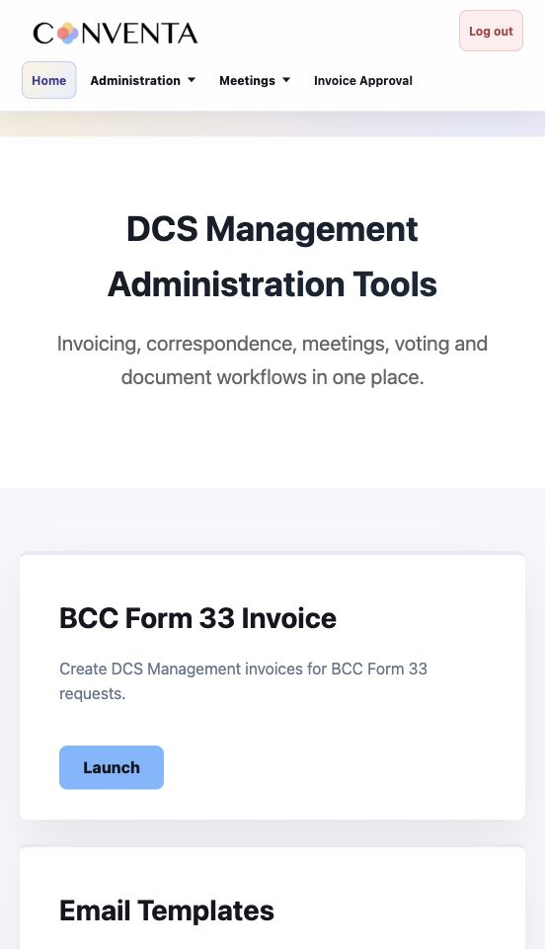
Conventa home dashboard

Home | Returns to the main tools dashboard.
Administration | BCC Invoice, Email Templates, Admin Docs, Nominations, Mailing Lists, and PDF Forms.
Meetings | Meeting Notices, Meeting Minutes, eVote Resource Center, and Tally Sheets.
Invoice Approval | Invoice approval portal and invoice management tools.

Administration Tools

BCC Invoice
Location: Administration > BCC Invoice
Purpose: Create DCS Management invoices for BCC Form 33 requests.
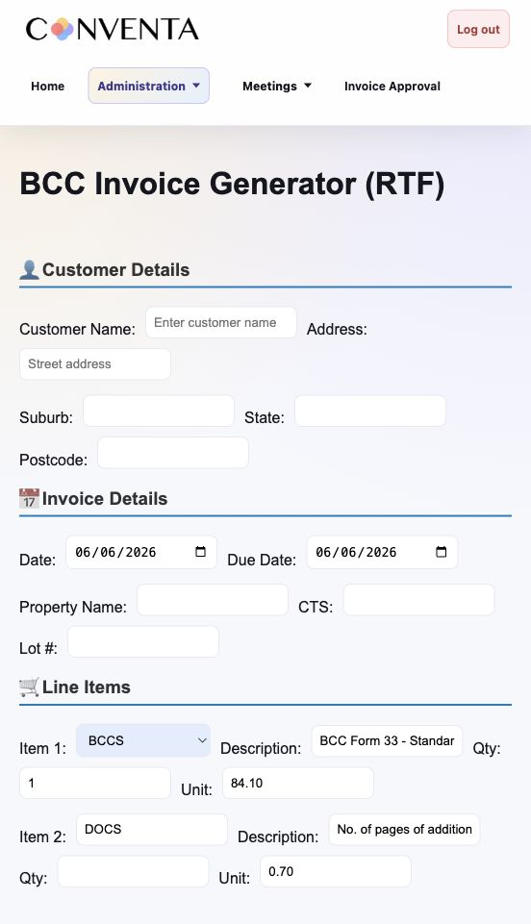
BCC Invoice

Workflow
- Open the BCC Invoice module.
- Enter the required property, invoice, and contact details.
- Review the invoice data.
- Generate or download the invoice output.

Notes
- Check the property name, CTS, invoice amount, and contact details before sending.

Email Templates
Location: Administration > Email Templates
Purpose: Generate standard email wording for notices, reminders, minutes, nominations, and recurring correspondence.
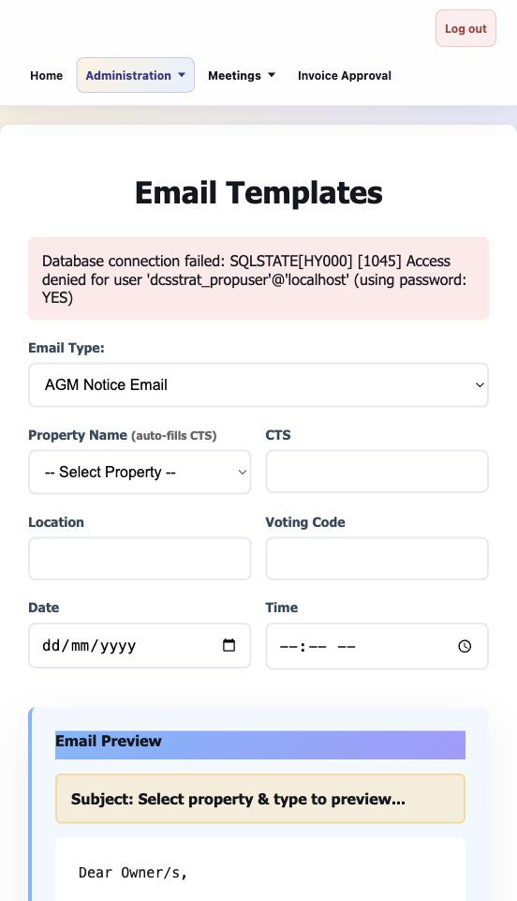
Email Templates

Workflow
- Select the required email template.
- Enter the property, recipient, meeting, or date details.
- Generate the email text.
- Review dates, attachments, names, and property-specific details before sending.

Admin Docs
Location: Administration > Admin Docs
Purpose: Generate administrative letters and standard documents.
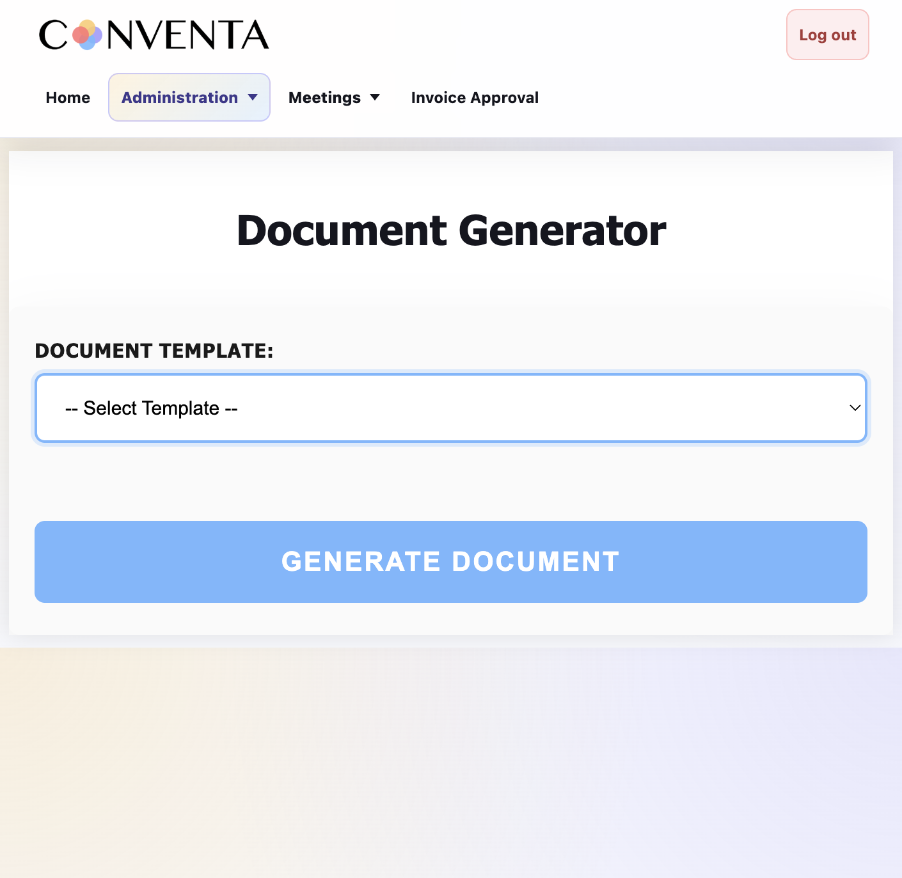

Workflow
- Select the document type.
- Complete the form fields.
- Generate the document.
- Review the document before issuing it.

Nominations
Location: Administration > Nominations
Purpose: Generate nomination and owner motion forms for Standard Module and Small Scheme Module properties.
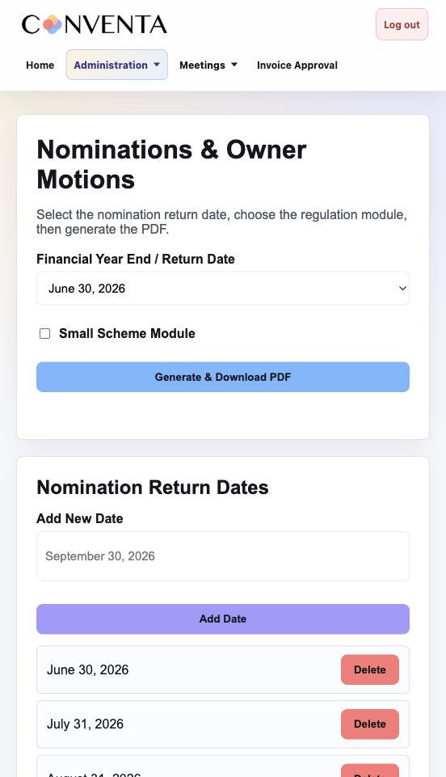
Nominations

Workflow
- Select the nomination return date.
- Choose the scheme/module option.
- Generate the nomination form PDF.
- Add or remove available return dates if needed.

Outputs
- Nomination/owner motion PDF.

Notes
- The module uses the saved date list and PDF templates stored with the app.

Mailing Lists
Location: Administration > Mailing Lists
Purpose: Create property manager mailing lists from PropertyIQ owner CSV exports.
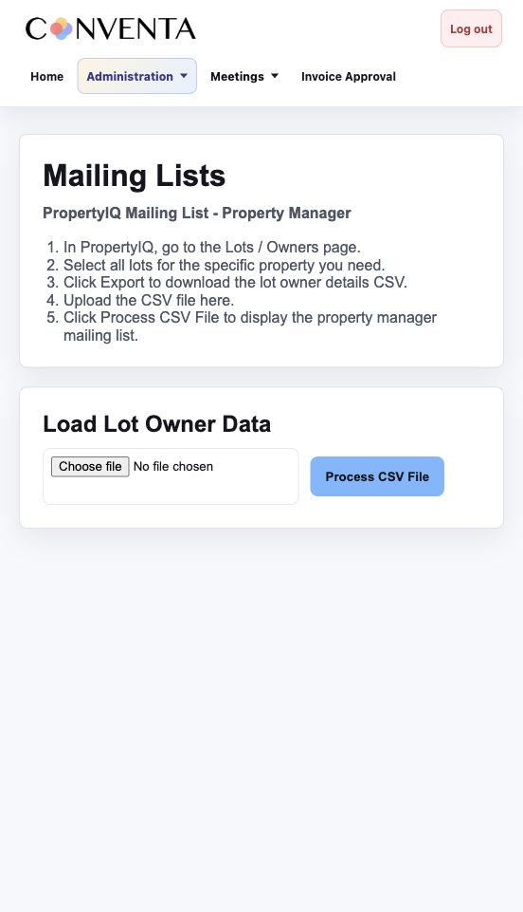
Mailing Lists

Workflow
- Export owner details from PropertyIQ Lots / Owners.
- Upload the owner CSV.
- Click Process CSV File.
- Review manager rows and use the duplicate-free BCC email link.

Outputs
- Manager results table.
- mailto BCC link.

Notes
- Required CSV columns: Building Name, Lot#, Unit#, Agent Name, Agent Email.
- Duplicate manager rows remain visible, but duplicate emails are removed from the BCC link.

PDF Forms (BETA)
Location: Administration > PDF Forms
Purpose: Batch-fill PDF forms from CSV data. This tool is specifically used for completing ATO Income Tax Returns.
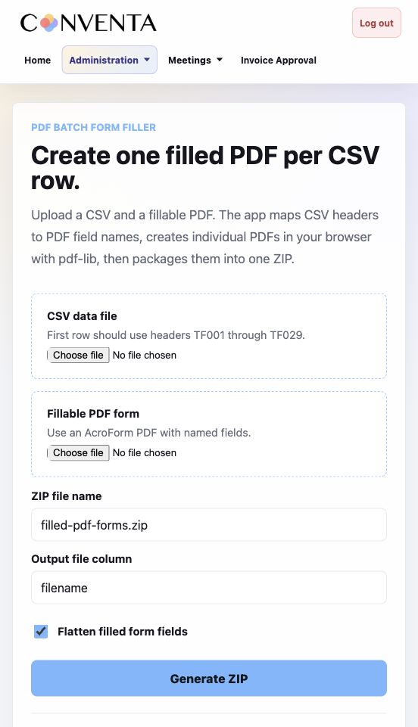
PDF Forms

Workflow
- Upload a fillable PDF template.
- Upload a CSV containing field values.
- Confirm the field mapping and filename column if required.
- Generate and download the ZIP of filled PDFs.

Outputs
- ZIP containing generated PDFs.

Notes
- CSV headers generally map to PDF fields such as TF001, TF002, and so on.

Meeting Tools

Meeting Notices
Location: Meetings > Meeting Notices
Purpose: Prepare meeting notices, DCS agreements, AGM checks, and LimeSurvey .lss eVote files.
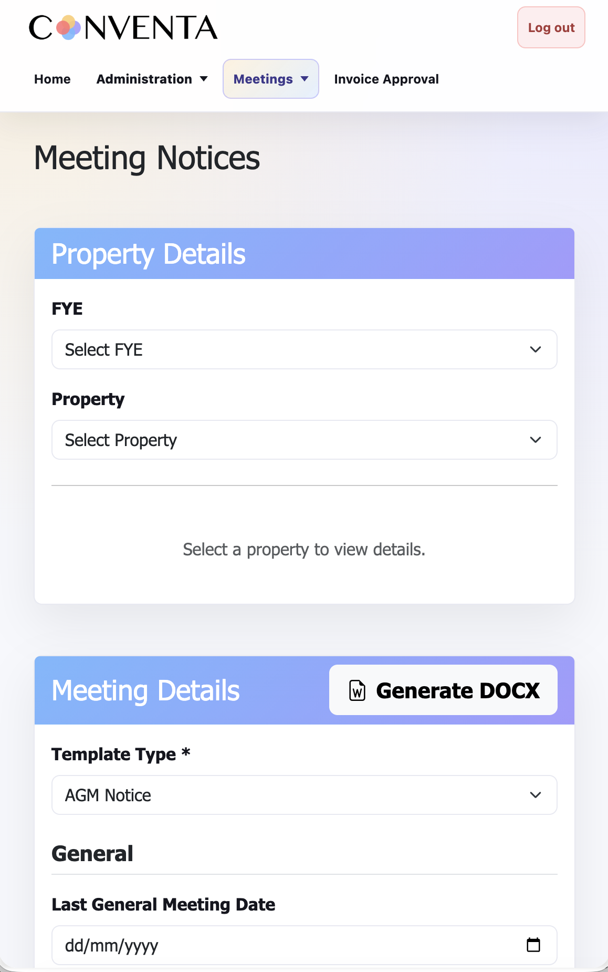

Workflow
- Select the property and FYE.
- Complete meeting details, financials, levy details, insurance details, BCM details, and motion fields.
- Click Generate DOCX to create the notice document.
- Click Generate LSS to create the eVote LimeSurvey file.
- Use Export JSON when notice/eVote data needs to be used by Meeting Minutes.

Saved JSON Naming
- [property]-FYE-[fye]-notice-[timestamp].json
- [property]-FYE-[fye]-evote-[timestamp].json
Screenshot not included in this DOCX because the local guide preview could not authenticate to the live property database for Meeting Notices.

Meeting Minutes (BETA)
Location: Meetings > Meeting Minutes
Purpose: Generate meeting minutes by combining saved notice/eVote JSON data with tally sheet data.
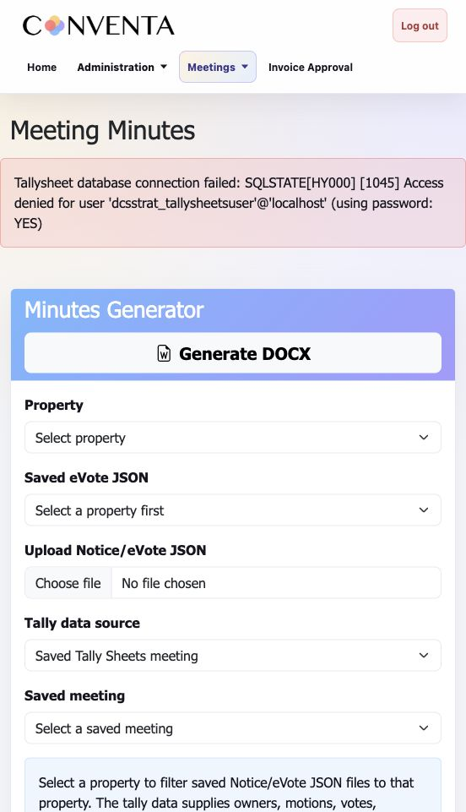
Meeting Minutes

Workflow
- Select the property.
- Select the saved eVote JSON file.
- Choose the tally data source.
- Upload the Tally Sheets transfer JSON if using uploaded tally data.
- Generate and review the DOCX minutes.

Outputs
- Meeting minutes DOCX.

Notes
- The saved eVote JSON and tally data should refer to the same property and meeting.
- The Tally Sheets transfer JSON field appears only when Upload Tally Sheets transfer JSON is selected.

eVote Resource Center
Location: Meetings > eVote Resource Center
Purpose: View active eVotes and download response data.

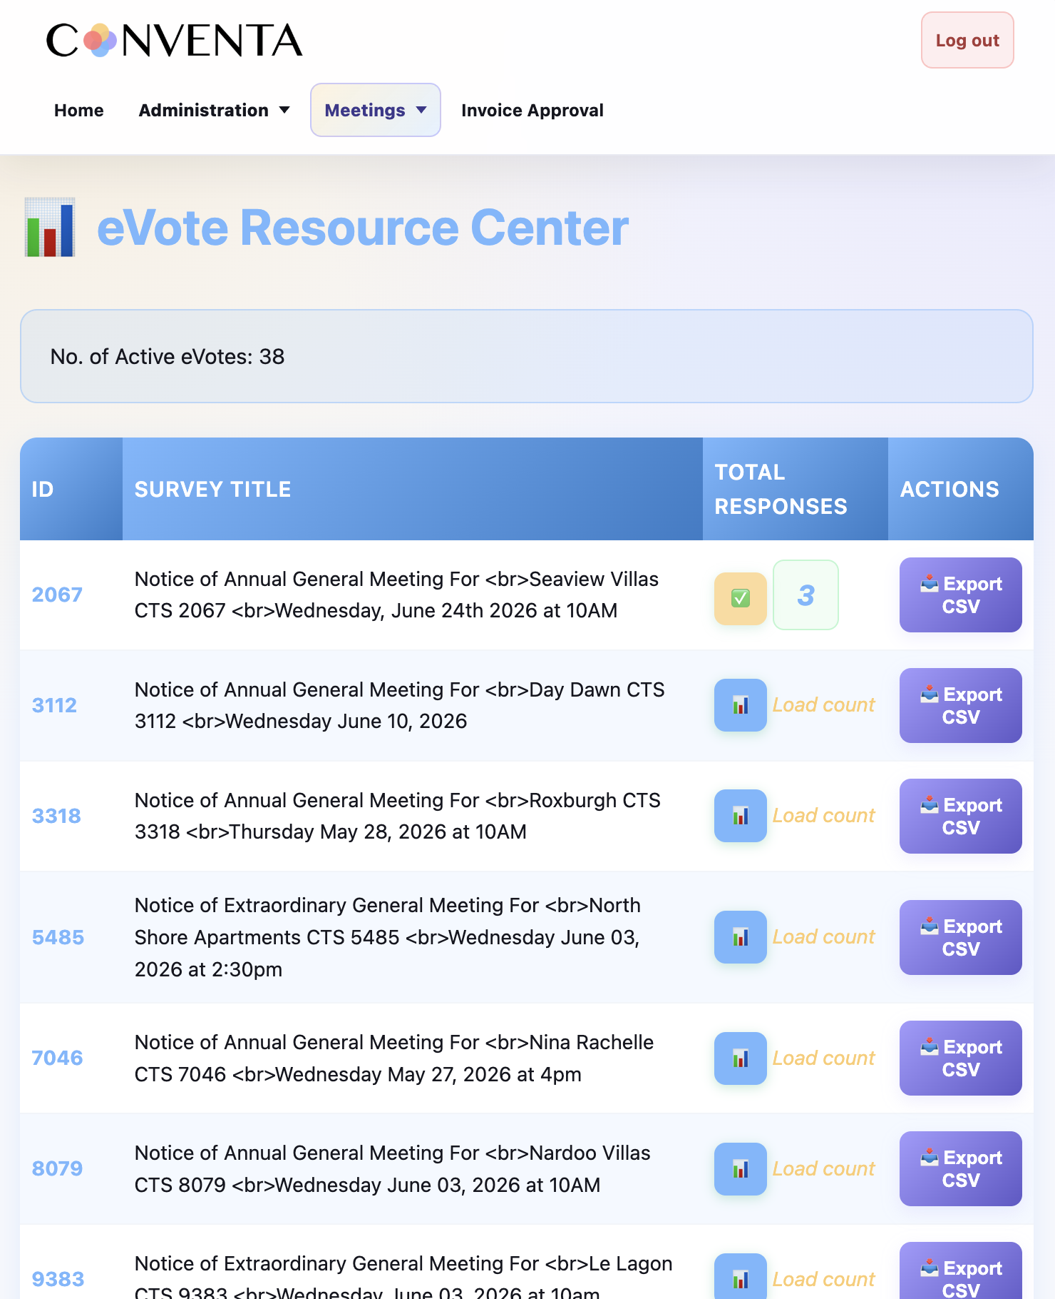

Workflow
- Open the eVote Resource Center.
- Review active eVotes.
- Download response CSV files as needed.
- Use response exports when autofilling tally sheet votes.

Tally Sheets (BETA)
Location: Meetings > Tally Sheets
Purpose: Create, edit, tally, save, and export meeting voting records.
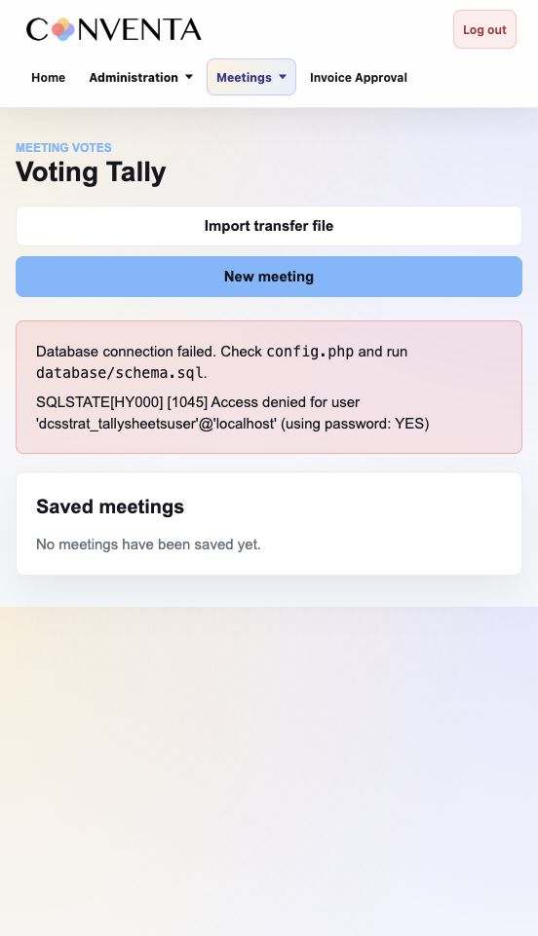
Tally Sheets

Workflow
- Create a new meeting.
- Enter property, meeting type, date, start time, location, quorum, chair, and returning officer.
- Choose Reconvened and Has Open Ballot where relevant.
- Upload the owner CSV and enter votes.
- Save the meeting and export CSV, Excel, or transfer JSON.

Outputs
- CSV export.
- Excel-compatible export.
- Transfer JSON.

Notes
- Owners without representation cannot vote.
- Owners with negative levy balances cannot vote.
- In Person, Company Nominee, and Proxy rows are green; Voting Paper rows are yellow.
- Open ballot nominee vote grids export only when Has Open Ballot is enabled.

Invoice Approval

Invoice Approval Portal
Location: Invoice Approval
Purpose: Review and manage invoices requiring committee approval.
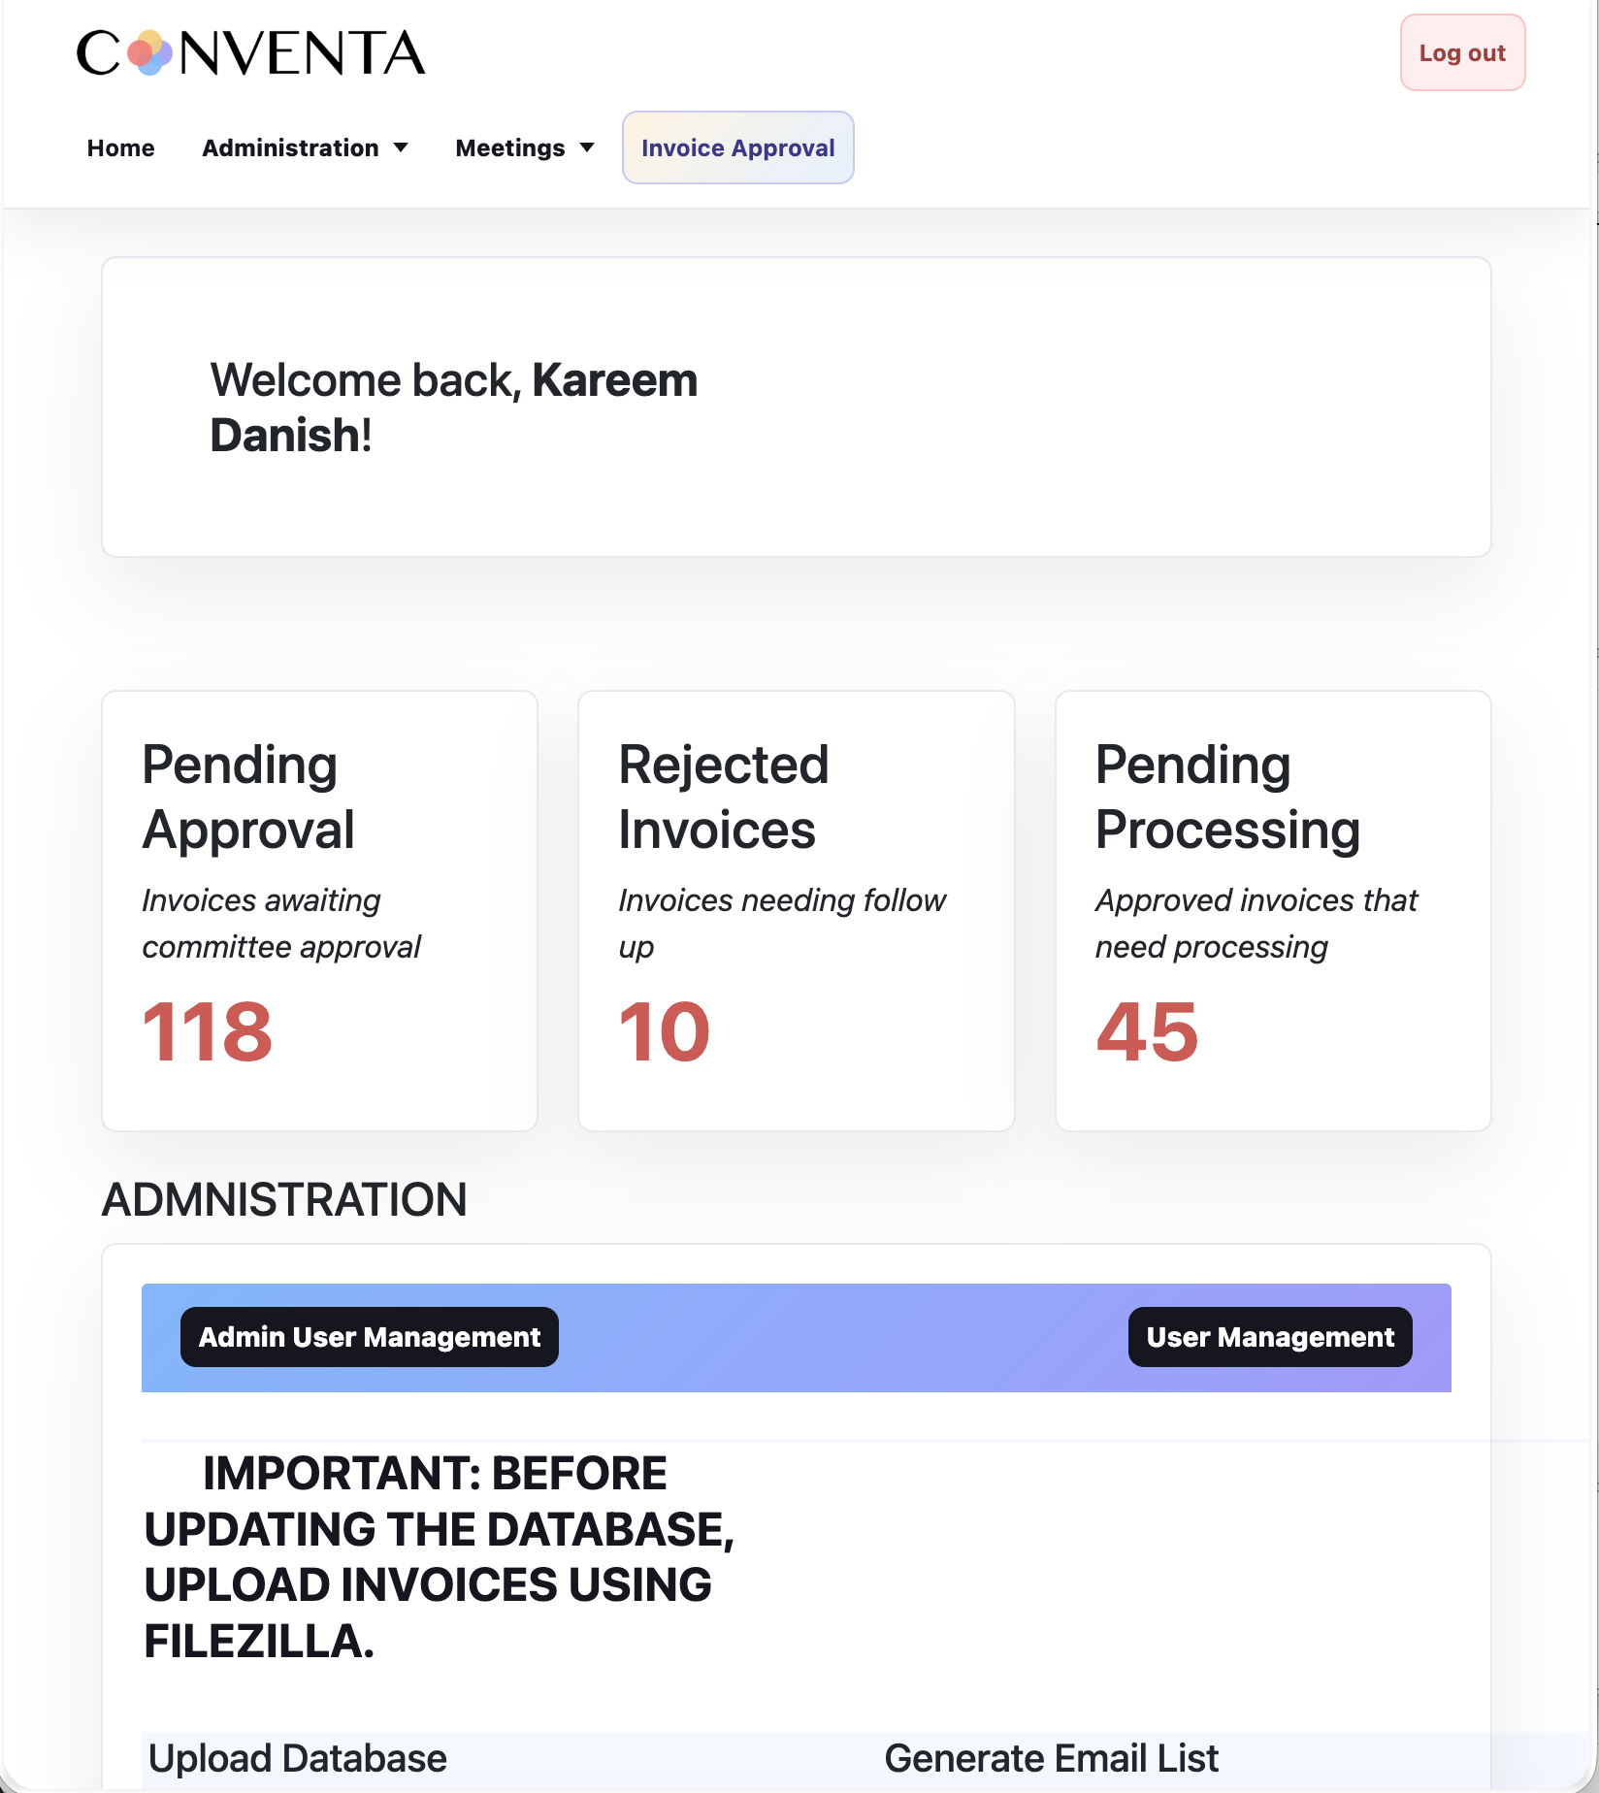
Invoice Approval Portal

Workflow
- Open Invoice Approval.
- Review invoice rows, CTS, supplier, invoice number, price, and status.
- Use filters or search where available.
- Use Load CTS to populate the CTS textbox with unique CTS values from rows where status is blank.
- Generate required approval outputs.

Notes
- Rejected status should display in red.
- Configured CTS values may be highlighted in red.

Offline Tallysheets (BETA)
The offline app is a browser-only version of Tally Sheets. It stores meetings in browser local storage and can export transfer JSON back into Conventa.
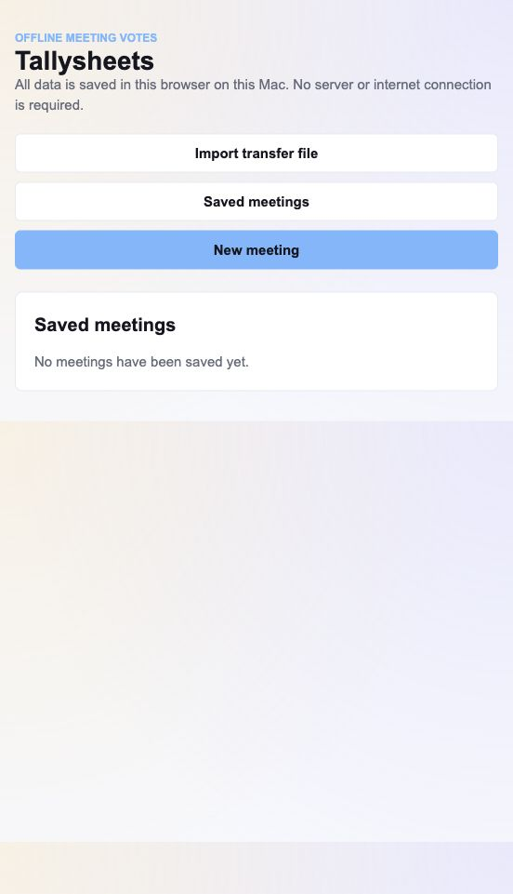
Offline Tallysheets app
- Open the offline app.
- Create a new meeting.
- Enter property name, CTS, meeting type, date, start time, and other details.
- Upload the owner CSV.
- Enter votes and office bearer details.
- Save the meeting in the browser.
- Export CSV, Excel, or transfer JSON.
Important: Offline meetings are saved only in the browser profile used to open the app. Clearing browser data may remove saved meetings, so export transfer JSON after important meetings.

Good Practice

Before Generating Documents
- Confirm property name and CTS.
- Confirm meeting date, time, chair, returning officer, and location.
- Check levy, insurance, BCM, and GST wording.
- Check motion wording and attachments.

Before Sending eVotes
- Confirm voting code, meeting date text, and expiry date.
- Check attachments and links.
- Import the .lss into LimeSurvey and review before activation.

Before Finalising Minutes
- Confirm saved eVote JSON and tally data refer to the same meeting.
- Review every motion result.
- Review attendance, representation, levy motions, and insurance motions.
- Open the generated DOCX and inspect formatting before sending.

